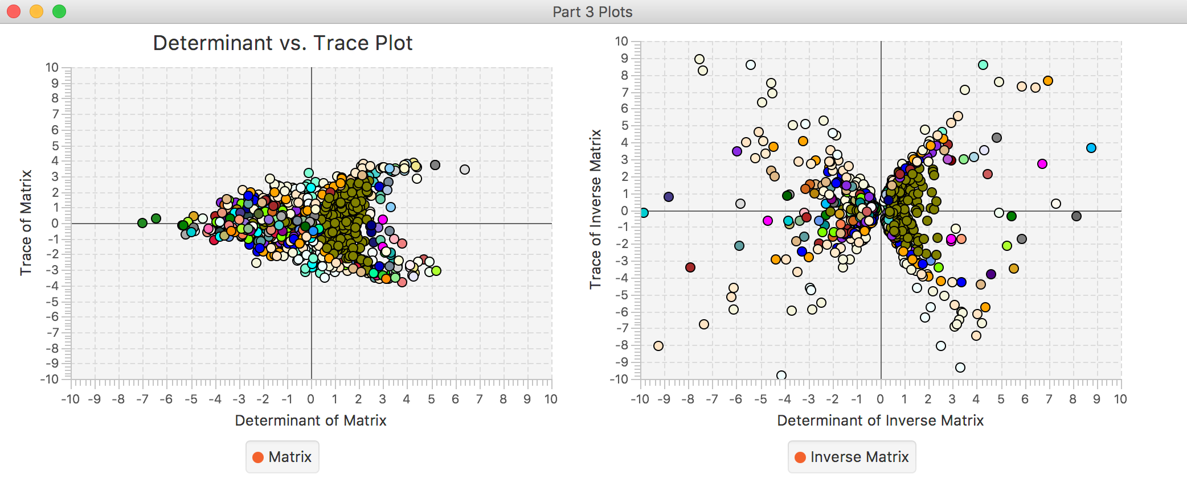**Part III:**

In both plots we can notice some fairly common things. Examining the points on both graphs we notice that the trace of the generated matrices and inverse matrices that the trace generally ranges from -2 to 2 (plus or minus some) and the determinant has a large concentration in this range as well. Examining the shape of the graphs, we notice that both graphs are parabolic around the x-axis while the inverse accentuates the shape a bit more in both directions. The reason being is the trace is the sum of a matrix’s eigenvalues while the determinant is the product of a matrix eigenvalues. The graph of the inverse matrix does not have values of trace when determinant is equal to zero because if the product of the eigenvalues is 0 then that must mean the eigenvalues either don’t exist or are 0. This is why the inverse graph begins to form a hyperbolic shape. This also explains the parabolic shape of the matrix plot because as the determinants get more negative that means you have negative eigenvalues and therefore the trace would approach zero when the eigenvalues are added. This explains why the matrix plot widens out because as the determinant becomes more positive it allows for higher fluctuation in the trace due to larger eigenvalues. Also in both graphs, you notice a higher amount of iterations when the determinant is from 0 to 2, and this is because of the limit on the matrices’ values. You will notice that in general, the inverse matrix uses less amount of iterations and that is because applying the power method on the inverse matrix allows for the eigenvalues/vectors to be converged on more rapidly. Finally, you will notice that the inverse plot reflects more accurate data in terms of determinant and trace (by noticing the hyperbolic shape as mentioned previously) and this is because the inverse power method is known to be more precise.